Inflation – workers are not to blame
Conversation Guide

Conversation guide

This template has been prepared to support union activists in conversation with workmates and with others in the community.
The template can be used for almost any conversation linked to inflation, economics, and the rising cost of living.
The purpose of the conversation would be to redirect the conversation away from workers as the cause of inflation, and bring focus to declining real wages, spiralling costs and profit driven inflation.

Those in power will try and say:
- Workers need to be modest in their claims, as business have been through tough times with COVID.
- Higher wage claims will increase inflation.
- The market of supply and demand will set wages.
- Proposed changes to industrial relations legislation and the introduction of sector bargaining will make companies uncompetitive.
These are some of the arguments that are used by employers and many journalists. The assumptions behind these arguments are incorrect.
The real experience workers have is:
- Declining real wages.
- Food, bills and travel are all rising, and the money we earn increasingly struggles to cover our costs.
- Insecure work has increased and done so at the expense of secure union jobs.
- Wage competition has driven down pay and conditions.

Conversation Structure
1: Question.  Ask questions of your workmates and friends. By asking questions we trigger the thoughts and participation of the people we speak to.  Questions are key to moving the person, questions like:  - How are you finding food costs and power bills?  - Are you cutting back on expenditure?  - Do you have a mortgage? What does rising interest rates mean to you and your family?  - What does it mean to you when costs of living continue to rise and wages don’t keep up?. | 2: Motivate.  To move the person you are speaking to, you need to engage them emotionally.  Parts of the discussion that aims to engage the person emotionally might look like:  - Working people like us have been struggling for a while, rising costs are causing real harm.  - Things are going to get worse. They’re talking about energy bills going up by 35%  - Throughout COVID many of us worked really hard to keep things going, and look at the way they have responded.
3. Education.  Move to provide the person with information that gives confidence to the decision to act.  You might achieve this by saying:  - We have no chance of getting a better deal on our own – unions have always organised to improve our conditions.  - We have to stick together – things only improve when we do stick together.  Incorporate a local story of unions winning. “Do you remember when...” | 4. Action.  We want the person to join, and stand with us. We want the conversation to move to the person agreeing to take action.  This part of the conversation might include:  - The person agreeing to join the union.  - Agreeing to be active  - Agreeing to talk to others in the workplace and community.

Graphs supporting your discussions
The Centre for Future Work is a new initiative, housed within the Australia Institute, to conduct and publish progressive economic research on work, employment, and labour markets. https://www.futurework.org.au

Wages Didn’t Cause Inflation  This graph shows how prices have risen, while wages have hardly changed since 2018 | 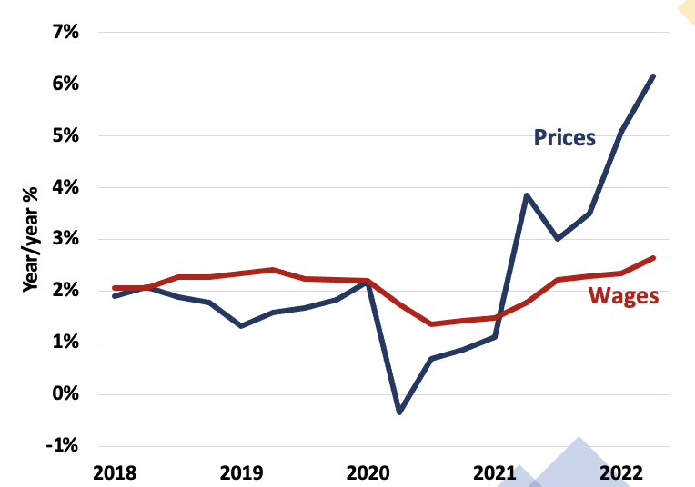
Real Wages are falling not rising.  This graph shows the change in real wages since 2018. You can see that real wages have fallen by 4% | 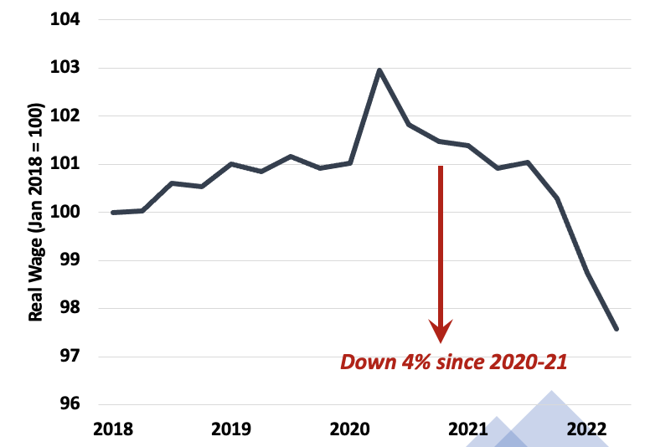
Labour Share of the Pie has Fallen  If you take all the money produced over a period of time in Australia, the percentage going to working people has been under continuous decline since the late 70s. | 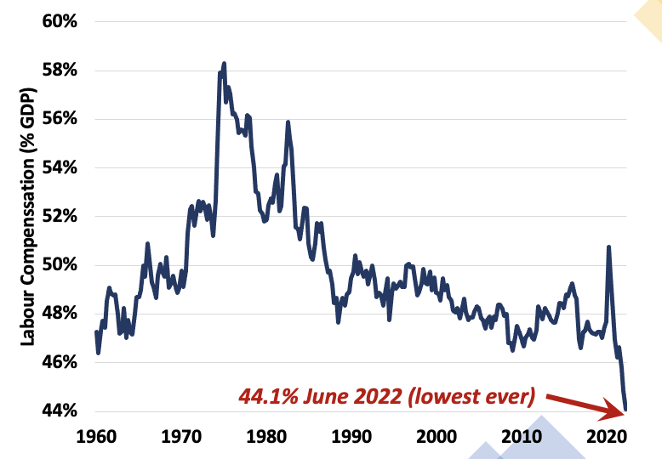
Inflation has Boosted Profits  Rising inflation has provided the opportunity for companies to raise the cost of a product and earn more profit. | 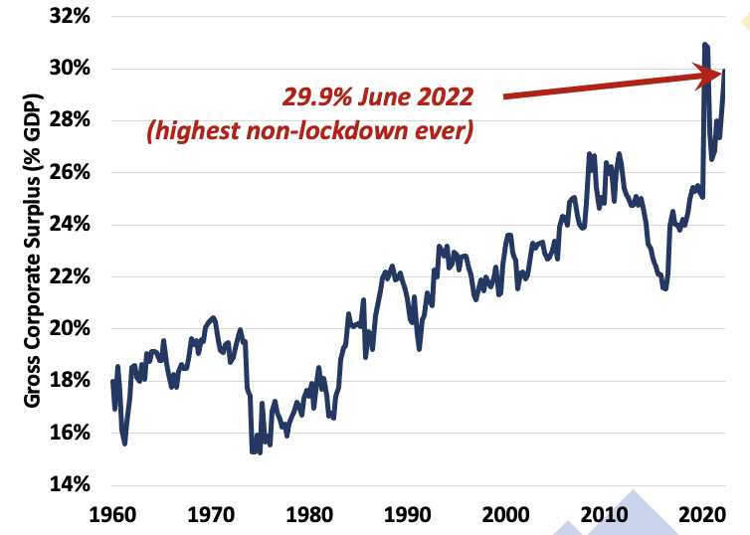
Profits and Wages  This graph shows how profits have been rising, the rate of the increase and how the rise of profits have outstripped wages. | 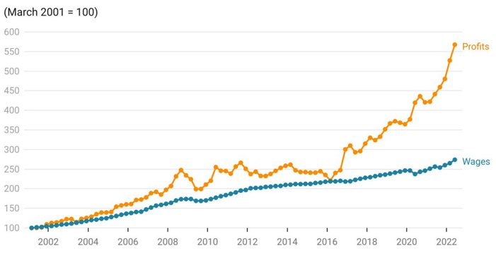

Links:
Australian Trade Union Institute inflation resource page: https://atui.org.au/inflation-seminars/
Centre for Future Work: https://www.futurework.org.au/

